Name: AMNA NASAR
Roll no:SU92-BSAIM-F25-128
Task 1
1950 – Turing Test:
Alan Turing introduced a test to check if a machine can behave like a human in conversation.
Source:
Turing Test (1950) – Alan Turing
Computing Machinery and Intelligence – Oxford Academic⁠￼
1956 – Dartmouth Conference:
AI became a separate field of study.
Source:
Dartmouth Conference (1956) and AI History
Stanford University – A Short History of AI⁠￼
1974–1980 – AI Winter:
AI development slowed down because of less funding and poor results.
Source:
First AI Winter (1974–1980)
OECD – A Short History of Artificial Intelligence⁠￼
1980s – Expert Systems:
Computers started using human knowledge and rules to solve problems.
Source:
Expert Systems (1980s)
UK Parliament – History of Artificial Intelligence⁠￼
1997 – Deep Blue:
IBM's computer defeated chess champion Garry Kasparov.
Source:
Deep Blue (1997)
IBM – History of Deep Blue⁠￼
2012 – AlexNet:
Deep learning became popular because computers could learn from copious amounts of data.
Source:
AlexNet (2012) and modern AI
MIT Lincoln Laboratory – AI History and Developments (PDF)⁠￼
Task2: Modified Rule-Based Program

Interpretation:
1: Complete high: Both systems give Review because all conditions are fulfilled.
2: Identity failure: Symbolic gives Hold because identity is not verified. Threshold gives Review.
3: Recommendation failure: Symbolic gives Hold because the recommendation letter is missing. Threshold gives Review.
4: Boundary: Both systems give Review because the score and probability meet the exact limits.
Failure analysis:
The probability-based system does not check individual conditions. It only checks the probability value. This can cause incorrect decisions when needed documents are missing.
Boundary test:
Change the score to 69 and probability to 0.69. Both systems should give Hold if all other conditions are True.
Connection to AI history:
Early AI systems used explicit rules. Modern AI systems use data and probabilities to show patterns. However, more data and faster computers do not guarantee correct decisions.

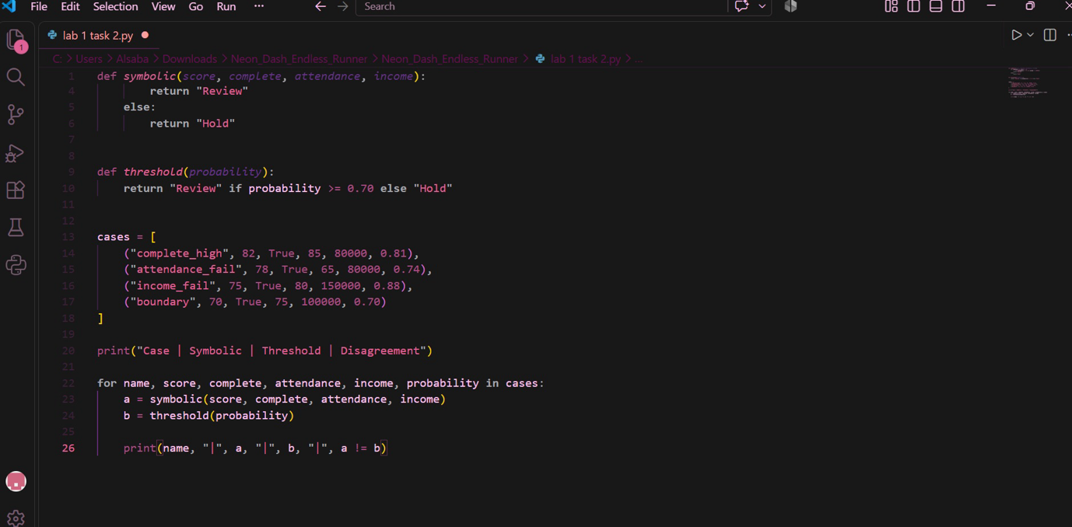
Task 3: Turing Test and General Intelligence
Why is passing a conversational test different from proving general intelligence?
The Turing Test checks whether a computer can communicate like a human. However, honest communication does not prove that a computer understands everything or can solve every real-world problem.
Scholarship example:
A chatbot may tell a student that their scholarship application is complete. However, an important document may be missing. This shows that effective communication does not always mean correct decisions.
More test for reliable performance:
We can provide different scholarship applications to an AI system and check whether it makes correct decisions. We can compare its results with verified answers and test it on new applications.
Conclusion:
Passing the Turing Test does not prove general intelligence. AI systems must also prove reliable performance in practical tasks.

